TinyML Framework and Library Analysis
In the field of TinyML, no single framework or library has yet emerged which implements all of the optimization techniques discussed so far. As such, various vendors involved in the embedded system ecosystem have created their own tools to assist in implementing these techniques. Immonen and Hämäläinen presented an overview of several of these tools, and we highlight the three most applicable here (2022).

The first framework discussed was TensorFlow Lite for Microcontrollers (TFLM), which is an open-source framework for running ML inference on embedded devices. It can be used with an assortment of ARM Cortex-M microcontrollers, and is widely supported by vendors such as Espressif and Arduino.

They then discuss the Cortex Microcontroller Software Interface Standard-NN or CMSIS-NN, developed by ARM. This library allows NN inference on ARM Cortex-M processors, and is specifically built to support low-level optimized versions of functions and networks such as Convolution layers and Softmax layers. This library is not typically used by itself, but rather integrated with other tools such as TFLM.

Finally, they discuss STM32Cube.AI, which is a NN and ML toolkit for the ST family of microcontrollers. This toolkit supports several advanced features such as automatic conversion of pretrained models and support for most other tools such as TFlite and keras, but is only supported for STM32 microcontrollers, leaving a large subset of ARM boards without support.
Several studies note that STM32Cube.AI produces reduced memory usage and faster execution times than TFLM, indicating that it might be preferable for STM32 devices (Hasanpour et al.,2025;Osman et al., 2022). ST also provides a cloud-based AI developer environment, which supports similar optimizations and additionally facilitates remote benchmarking of inference performance across a multitude of their boards using a server board-farm (“ST Edge AI Developer Cloud,” 2023).

The figure below illustrates a typical toolchain for a TinyML workflow.

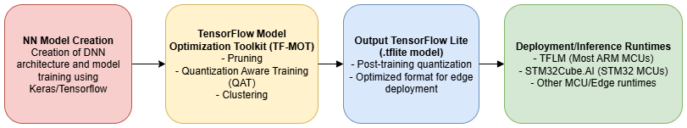
Figure X: Example of a typical TinyML toolchain for training/inference on an embedded device.

Comparison of Neural Network Architecture Performance
Lara-Benítez et al. compared the performance of seven popular NN architectures, including MLPs, CNNs and LSTMs, in time-series forecasting tasks across twelve datasets (2021). These time series forecasting tasks were found to have a critical component in a plethora of research areas such as energy consumption, retail sales and, most importantly for us, weather.

For evaluating the performance, instead of using the Mean Absolute Error (MAE), the most commonly used metric for evaluation, they chose instead to use a weighted error (termed the Mean Absolute Percentage Error, MAPE) by dividing the MAE by the mean of the dataset. This allowed them to obtain an error that could be compared across multiple time series datasets.

After statistical analyses of the MAPE of each architecture in each dataset, they found that the MLPs generally performed the worst, and the LSTMs and CNNs performed the best (had the lowest MAPEs).

When considering efficiency of the architecture (length of time required for both training and inference), MLPs were found to perform the best, with CNNs following right after. This led them to conclude that CNNs resulted in the best speed/accuracy tradeoff.

They also suggested that CNNs generally performed best for time series forecasting with four layers, and no max-pooling layers. There was no conclusive evidence on the best number of filters to utilize. This provided a good starting point for our own implementation.

In the next section, we draw on all of the knowledge we reviewed thus far to set up our own experiment.

